**Setting Windows scheduler to update the**

1. Install miniconda.
2. Add in the environmental path variables de activate command from anaconda:

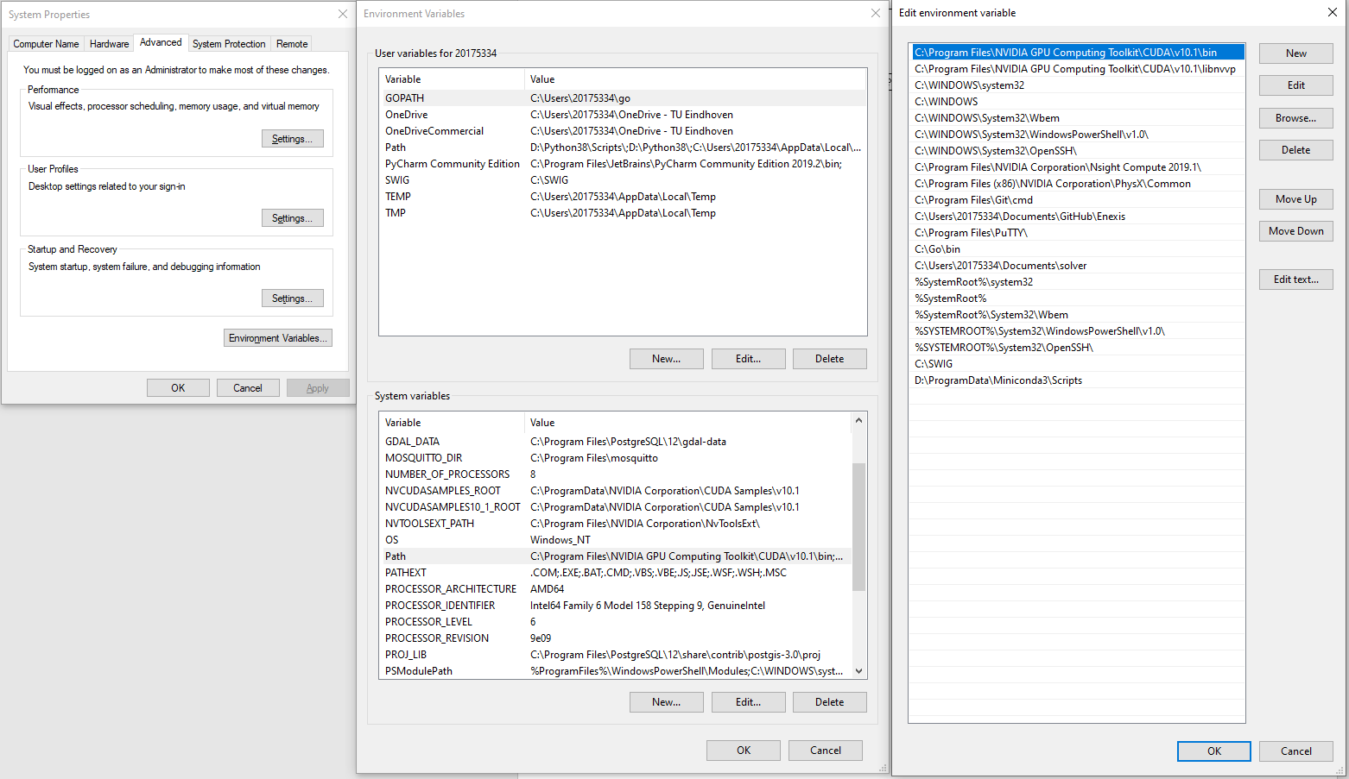

1. Write the update.bat script:

@echo off

Call activate knmi_api

"D:\ProgramData\Miniconda3\envs\knmi_api\python.exe" "C:\Users\20175334\Documents\PycharmProjects\knmi_api\update_file.py"

1. Done!